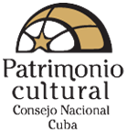 |  |  | XVI International Conference MINOM Community museology and sociomuseology  6 oct 11 oct 2014  Havana - Cuba |  |  |  |  | 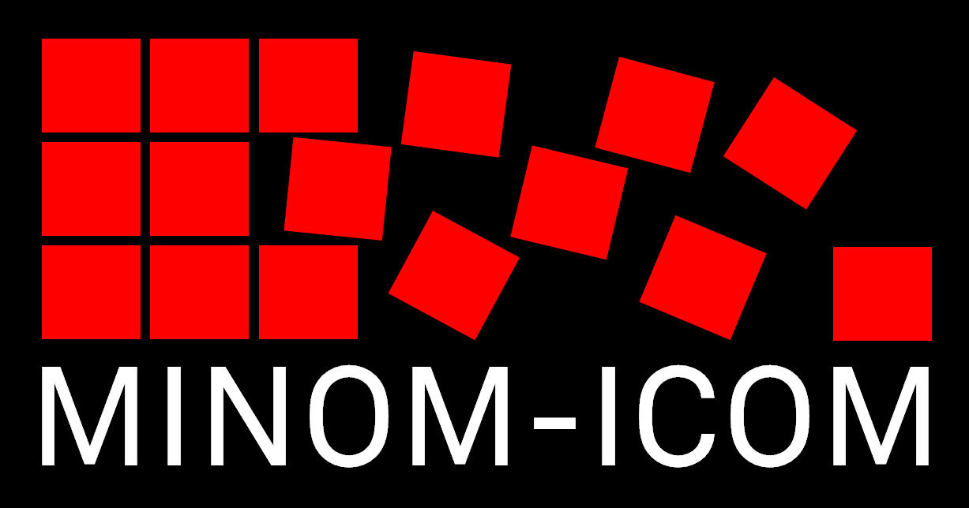
Preliminary program

Pre-conference training workshop
Community museology 6 oct – 9 oct

6 oct. | 9:30-12:30 |  |  | Opening training workshop |  | Opening conference:  Sociomuseology, community development and popular museology, Mario Chagas  Community museology practice at an international level - MINOM, Paula Assunção  Community museology practice in Cuba:  - The experience of municipal museums in Cuba. The Matachín museum, 32 years of community work, Alejandro Harman  - A museum that emerged from the people and its social impact, María Cristina Peña  - Feedback community-museum, Pedro Cosme
 | 14:00-18:00 |  |  | Study visits |  | Paths and Walks project, Historical Office of the city
7 oct. | 9:30-12:30 |  |  | Workshop |  | Museologie and sociomuseology (Rio Declaration) Mário Moutinho  - Popular museology in Cuba: law n°23 creating municipal museums, María de las Mercedes García Santana  - Museum communication in Cuba, a challenge for the XXIst century?, Dory Castillo Garriga  - The birth of museums in the ancient province of Havana , Lelis Marrero Oliva
 | 14:00-18:00 |  |  | Study visits |  | National Museum of Decorative Arts
8 oct. | 9:30-12:30 |  |  | Workshop |  | Participation, networks and citizenship  MINOM  - Paths and Walks project, OHC  - Güineros walks, Odalys Morales Pino y Erminia M. Curbelo Vasallo  - The project Mule drivers and fantasies from the mountain, Ledesme Garcés Rosales  - Experience of museology and community heritage in an area that was declared a World Heritage Site, Ileana Donatien
 | 14:00-18:00 |  |  | Study visits |  | Sociocultural project Cabildo Quisicuaba
9 oct. | 9:30-12:30 |  |  | Workshop |  | The museum as a social service: education, tourism, inclusion, development  Mário Moutinho- MINOM  - The museum as a cultural option for the development of national and international tourism, Adela Lorente Febles  - The ecomuseum Las Terrazas, origin and memory, Analia Piña Cordero  - Traces of love project, an educational and pedagogical museological practice, Ileana Donatien
 | 14:00-18:00 |  |  | Study visits |  | To be determined
 | 20:00-22:00 |  |  | Tribute to Marta Arjona and to the 30th anniversary of the Quebec Declaration |  | National Museum of Fine Arts
XVI International Conference MINOM
Community museology and Sociomuseology
9 oct – 11 oct

10 oct |  | 9:30-12:30 |  |  | Official opening of the XVIth Conference |  | Opening conference  International practice of community museology, Mario Chagas  Community museology practice in Cuba, José Linares
 |  | 14:00-18:00 |  |  | Working groups |  | Working group 1: Public policies for culture and museology  Working group 2: Local museums: documenting and exhibiting  Working group 3: Networks of paths and local heritage
11 oct. |  | 9:30-12:30 |  |  | Working groups |  | Working group 1: Public policies for culture and museology  Working group 2: Local museums: documenting and exhibiting  Working group 3: Networks of paths and local heritage
 |  | 14:00-16:00 |  |  | Working groups |  | Working group 1: Public policies for culture and museology  Working group 2: Local museums: documenting and exhibiting  Working group 3: Networks of paths and local heritage
 |  | 16:00-18.00 |  |  | Plenary session and closing of the conference
 |  | 20:00-23:00 |  |  | Closing party |  | Terraza del Hotel San Miguel

National Council of Cultural Heritage - Ministry of Culture of Cuba and
International Movement for a New Museology MINOM-ICOM

